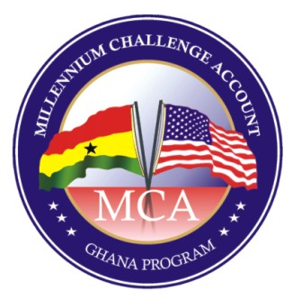

Millennium Development Authority (MiDA)

Re: Upgrade of the Electricity Company of Ghana Limited (ECG) Data Center & Communication Network
***
CB No: 5120400-01/IFB/CB/11/18
-------------------------------------------------------
ADDENDUM NO. 1 TO BIDDING DOCUMENT
------------------------------------------------------

In accordance with ITB Clause 11 of the Bidding Document for the above-mentioned Sub-Activity of MiDA, the following attached amendments to the Bidding Document are being issued in the form of Addendum No. 1.

- Amendment No. 1-District- Sites
- Amendment No. 2-ECG Bandwidth capacity task4 Ver 2.0
- Amendment No. 3-Equipment-count
- Amendment No. 4-Training (003)_ECG
- Amendment No. 5-List-sites
- Amendments Nos. 6 –10- Miscellaneous

This information on Addendum No. 1 will be sent in writing to all prospective Bidders that have registered and received this Bidding Document.

This information with the individual amendments, can be found on the MiDA website at www.mida.gov.gh.

Prospective Bidders who have yet to register their details with the MiDA Procurement Agent and wish to receive this information, are hereby reminded of Clause 10 of the Specific Procurement Notice and Letter of Invitation for Bid (IFB), as reproduced below:

“Prospective Bidders interested in submitting a Bid should request the Bidding Document by sending an e-mail, giving full contact details (full physical address, phone numbers and email address(es)) of the organization and relevant contact person(s) to the MiDA Procurement Agent at paghana@charleskendall.com.” The Bidding Document, and any subsequent documentation, will be issued, on receipt of a complete request, by the MiDA Procurement Agent.

Chief Executive Officer
Millennium Development Authority (MiDA)
4th Floor Heritage Tower, 6th Avenue. Ridge West, Accra, Ghana.

Addendum No. 1 Issued Date: 19th January, 2019.

